**Game store e commerce project**

**Mohammad Hani Issa Khrabeh 202110986**

**Problem statement:**  
In the rapidly growing gaming industry, players and enthusiasts seek a seamless and convenient platform to purchase games, consoles, accessories, and related merchandise. However, existing online game stores often face several challenges, including limited product availability, poor user experience, inefficient search functionality, lack of secure payment options.

Many gamers struggle with:

* Fragmented Shopping Experience – Difficulty in finding all gaming-related products in one place.
* Limited Payment Options – Lack of diverse and secure payment methods for customers.
* Poor Navigation and Search – Inefficient product discovery
* Slow or Unreliable Customer Support – Delays in addressing order issues, refunds, or product inquiries.

|  |  |  |  |
| --- | --- | --- | --- |
| **Business case** | | | |
| **Project sponsor** | Mohammad | **Project manager** | Ahmad |
| **Problem statement** | existing online game stores often suffer from limited selections, poor user experience, and inefficient customer support. | | |
| **Solution** | * A user-friendly interface. * A vast library of games. * Secure payment gateways and multiple payment options. * 24/7 customer support. * review system. | | |
| **Costs** | * Website development: $5,000 - $10,000 * Hosting and infrastructure: $1,000 annually * Payment gateway integration: $500 * Maintenance and updates: $1,000 - $2,000 annually | | |
| **Benefits** | * Increased revenue potential through online sales. * Scalability and expansion opportunities to local markets. * Lower overhead costs compared to brick-and-mortar stores. | | |
| **Scope** | * Development of a fully functional e-commerce website. * Integration of secure payment gateways. * Implementation of a recommendation engine. * Ongoing website maintenance and feature enhancements. | | |
| **Risks** | * Technical failures. * Cybersecurity threats. * High competition. * Scalability issues. | | |

**Planning and requirements gathering:**

1. **Market Research:** Analyzing industry trends, customer preferences, and competitor offerings.
2. **Stakeholder Consultation:** to identify key requirements.
3. **Feature Identification**: Listing essential features such as search and filter options.
4. **Technology Selection:** Choosing the right tech stack, including programming languages, hosting solutions, and payment gateway providers.
5. **Project Timeline**: Defining milestones for development, testing, deployment.
6. **Budget Allocation:** Estimating costs for development, operations, and marketing.
7. **Risk Assessment:** Identifying potential risks and mitigation strategies.
8. **Compliance and Security.**

**Software Development Life Cycle (SDLC) Model:**

* **Requirement Analysis:**

1. Gather detailed functional and non-functional requirements.
2. Identify business and technical needs.
3. Document requirements for iterative development.

* **Planning:**

1. Define scope, objectives, and deliverables.
2. Allocate resources and create project timelines.
3. Identify risks and establish mitigation strategies.

* **Design:**

1. Develop prototypes for UI/UX.
2. Ensure scalability and security compliance.

* **Development:**

1. Implement core features such as user authentication, product listings, and payment processing.
2. Develop personalized recommendation algorithms.
3. Conduct continuous testing.

* **Testing:**

1. Perform unit, integration, and system testing.
2. Conduct security and performance testing.
3. Gather user feedback for iterative improvements.

* **Deployment:**

1. Launch the website in a staging environment.

* **Maintenance & Updates:**

1. Monitor system performance and security.
2. Release periodic updates with feature enhancements.
3. troubleshooting.

**Functional requirements:**

1. User registration and login.
2. Product catalog and search.
3. Shopping Cart & Checkout.
4. Order Management.
5. Recommendation System.

**Use case:**  
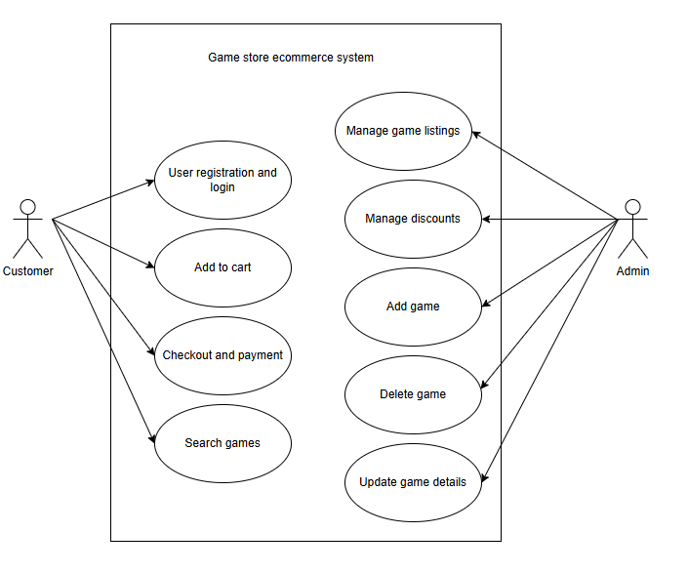

**Gantt chart:**  
